DS-A1 | Data Provenance and Measurement Audit

Access git-hub: https://github.com/alldeolove10-SJ/2026A8000531008_DEONISIO-YOHANES-WILFRIDUS-HORNAY_Week3_DS_A1_Data-Provenance-and-Measurement-Aud

Worked submission draft - UCI Iris dataset
Source: UCI Machine Learning Repository, Iris, DOI 10.24432/C56C76
URL: https://archive.ics.uci.edu/dataset/53/iris
License: CC BY 4.0
Frozen file: data/iris_frozen.csv
SHA-256: 7e4e13e60d330d83ae5309b440eb5ececb4b779e925cc621d8f347b1e14eeca3

Question and measurement boundary
Question: Within this dataset, how well do petal measurements separate the three recorded iris species, and what data-quality limitations constrain that conclusion?

Element | Definition
Stakeholder | Teaching/research team demonstrating measurement-aware exploratory data science
Population | Iris flowers of the three represented species under comparable measurement procedures
Sample | 150 measured flowers in the frozen copy
Unit | One flower
Target | Recorded species label
Estimand | Difference in mean petal length between species groups in this observed sample

Provenance lineage
Real iris flower -> physical sepal/petal measurements and species assignment -> historical dataset compilation -> UCI repository -> frozen local CSV -> pandas audit and descriptive analysis. Measurement, labeling, transcription, repository transformation, and preprocessing are all potential error points.

Audit results

Check | Result
Rows / columns | 150 / 5
Missing values | 0
Exact duplicate rows | 1
Classes | setosa, versicolor, virginica
Positive numeric measurements | Yes

IQR-based anomaly flags are treated as prompts for review rather than proof of error. A later predictive model must exclude the species target from predictor features and must fit preprocessing without using test-set information.

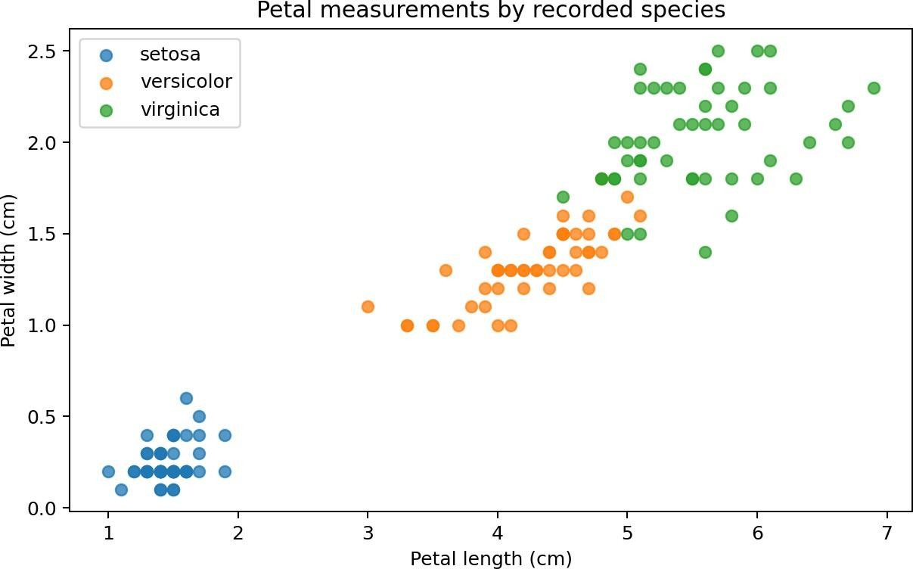

Figure 1. Petal length versus petal width by recorded species.Bias / measurement counterexample

If the flowers were collected from a narrow geography, cultivar set, or environmental range, the observed species separation may remain true for this sample while failing to describe other settings. The equal count of 50 observations per species is convenient for analysis but is not evidence that the species occur equally often in nature.

Prohibited claims
Do not claim: “Petal size causes an iris flower to become a particular species.” The data are observational measurements of already-existing flowers and do not identify a causal intervention. Also do not claim that the 150 observations are representative of all iris flowers worldwide without additional sampling evidence.

Findings and limitations
The frozen dataset contains 150 observations, four numeric measurements, and three species labels. It has no missing values in this representation and contains one exact duplicate row. Petal measurements show strong sample-level separation, especially for setosa, but the conclusion is descriptive and bounded to this dataset.
Limited collection metadata constrain external validity and the duplicate row means row independence should not be assumed automatically.

Reproducibility and AI verification
The accompanying notebook is executable top-to-bottom, fixes a random seed, verifies the frozen file hash, performs schema/missingness/duplicate/range/anomaly/leakage checks, writes raw audit results, and saves the plot. AI was used to help structure and draft the work. The student should personally run the notebook, inspect outputs, and add any rejected AI advice or manual checks before submission.

Submission checklist
  - Executed notebook

  - This PDF report

  - Data Card and data dictionary

  - Frozen source data, license/source record, and SHA-256

  - AI-use and independent-verification log

  - 150-300 word result summary on the platform

  - Stable GitHub repository URL with commit/tag

